Clean Code Principles - Organize Code Properly
# Source: AI Source: Provided by: [Data Path: Persons Table -> ID Column: 1, Name_En Column: Motasem Essam] -> From: [Chatgpt (GPT‑5 Mini)] on [12/9/2025]
Organizing code properly means structuring your codebase in a clear, logical, and consistent way so it’s easy to navigate, understand, and maintain.

🔑 Why Organization Matters
# Source: AI Source: Provided by: [Data Path: Persons Table -> ID Column: 1, Name_En Column: Motasem Essam] -> From: [Chatgpt (GPT‑5 Mini)] on [12/9/2025]
- Makes code easier to read and navigate
- Helps developers find things quickly
- Improves scalability as the project grows
- Reduces confusion and duplication

✅ Good Example (Well Organized Structure)
# Source: AI Source: Provided by: [Data Path: Persons Table -> ID Column: 1, Name_En Column: Motasem Essam] -> From: [Chatgpt (GPT‑5 Mini)] on [12/9/2025]
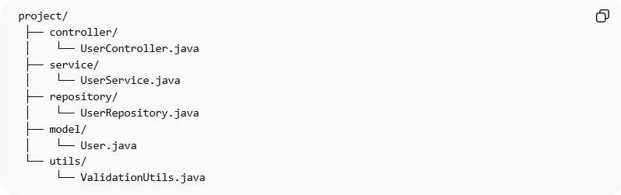
project/
├── controller/
│ └── UserController.java
├── service/
│ └── UserService.java
├── repository/
│ └── UserRepository.java
├── model/
│ └── User.java
└── utils/
└── ValidationUtils.java
👉 Each folder has a clear responsibility
👉 Related code is grouped together

❌ Bad Example (Poor Organization)
# Source: AI Source: Provided by: [Data Path: Persons Table -> ID Column: 1, Name_En Column: Motasem Essam] -> From: [Chatgpt (GPT‑5 Mini)] on [12/9/2025]
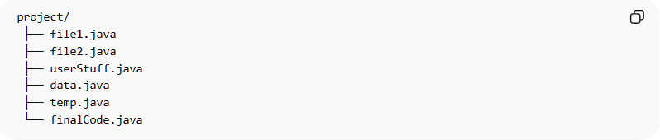
project/
├── file1.java
├── file2.java
├── userStuff.java
├── data.java
├── temp.java
└── finalCode.java
👉 Problems:
- No structure
- No clear responsibilities
- Hard to navigate
- Confusing naming

📦 Another Example (Inside a Class)
# Source: AI Source: Provided by: [Data Path: Persons Table -> ID Column: 1, Name_En Column: Motasem Essam] -> From: [Chatgpt (GPT‑5 Mini)] on [12/9/2025]
❌ Bad:
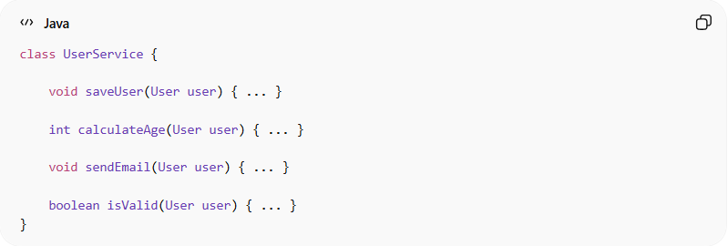
class UserService {

void saveUser(User user) { ... }

int calculateAge(User user) { ... }

void sendEmail(User user) { ... }

boolean isValid(User user) { ... }
}
👉 Mixed responsibilities, no clear grouping

✅ Good:
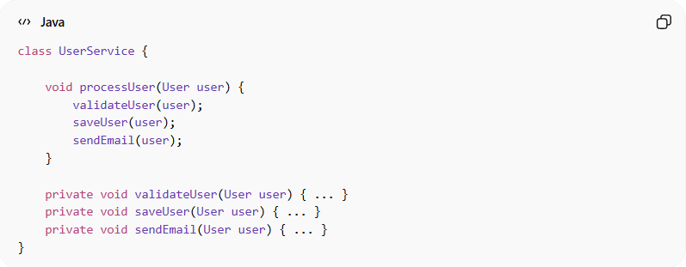
class UserService {

void processUser(User user) {
validateUser(user);
saveUser(user);
sendEmail(user);
}

private void validateUser(User user) { ... }
private void saveUser(User user) { ... }
private void sendEmail(User user) { ... }
}
👉 Clear flow and grouped logic

🧭 Best Practices
# Source: AI Source: Provided by: [Data Path: Persons Table -> ID Column: 1, Name_En Column: Motasem Essam] -> From: [Chatgpt (GPT‑5 Mini)] on [12/9/2025]
1. Group Related Code Together
- Keep related classes and functions in the same module/package

2. Follow a Clear Structure
- Use layers (Controller → Service → Repository)
- Or organize by feature/domain

3. Keep Files Focused
- One class per file (in most cases)
- Avoid huge files

4. Use Logical Naming
- Folder and file names should reflect purpose

5. Organize by Feature (Advanced)
Instead of technical layers:
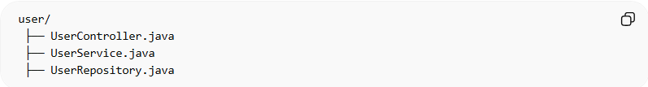
user/
├── UserController.java
├── UserService.java
├── UserRepository.java
👉 Groups everything related to “User” together

💡 Key Idea
# Source: AI Source: Provided by: [Data Path: Persons Table -> ID Column: 1, Name_En Column: Motasem Essam] -> From: [Chatgpt (GPT‑5 Mini)] on [12/9/2025]
Good organization means someone can understand your project without asking you.

🚫 Common Mistakes
# Source: AI Source: Provided by: [Data Path: Persons Table -> ID Column: 1, Name_En Column: Motasem Essam] -> From: [Chatgpt (GPT‑5 Mini)] on [12/9/2025]
- Mixing unrelated logic in one file
- Poor folder naming (misc, temp, helpers)
- Huge classes with many responsibilities
- Random file placement

🧾 Summary
# Source: AI Source: Provided by: [Data Path: Persons Table -> ID Column: 1, Name_En Column: Motasem Essam] -> From: [Chatgpt (GPT‑5 Mini)] on [12/9/2025]
Organizing code properly helps you:
- Navigate code faster
- Reduce confusion
- Improve maintainability
- Scale your project easily

